The provided code can be used to manually place regions of interest –ROIs (specified as binary masks) onto a DICOM file.

**INTRO:**

In MATLAB, RTSTRUCT information is handled as a dicomContour object, which is defined in the homonymous class “dicomContour.m” of the “Image Processing toolbox”. For the purposes of this work, this class was modified, however, due to copyright issues, we are not able to provide the code. We opted to provide detailed instructions on how to obtain the modified class from the original MATLAB class (“Utilities/How to create dicomContours.docx”).

**USAGE STEPS:**

1. Generate the modified “*dicomContours.m”* class.
2. Place in the “Image” folder the DICOM file (and the RTSTRUCT) of the image you want to use as a basis for your phantom.
3. Run the “Main” script.
4. When the interactive window shows up, specify in the upper-right corner the file containing your ROIs. You can use the default “*mask_template.mat*” file provided in the folder as an example.
5. Place the ROIs on the Image with a left-click. If needed, ROIs can be deleted with a right-click. ROIs will be automatically anchored to the grid points (which can be modified in number and position using the corresponding parameters on the bottom of the window). ROIs can be rotated ahead of being placed on the image, using the dedicated buttons (⭯).
6. Close the interactive window.
7. The RTSTRUCT file of the generated ROIs is automatically created in the Output folder.

**CREATE CUSTOM ROIs:**

Users should design custom ROIs and store them in the same format as the “*mask_template.mat”*. “*Mask_template.mat”* contains a cell array having in the first column {:,1} the ROI masks (binary masks saved as logical arrays), in the second column {:,2} the ROI name and in the third one {:,3} a three-value array specifying the colours of the ROI contour specified in the RGB format (e.g., white = [255 255 255]).

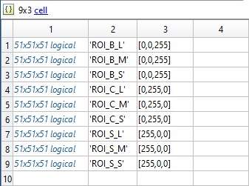

**DISCLAIMER**

THE SOFTWARE IS PROVIDED "AS IS", WITHOUT WARRANTY OF ANY KIND, EXPRESS OR IMPLIED, INCLUDING BUT NOT LIMITED TO THE WARRANTIES OF MERCHANTABILITY, FITNESS FOR A PARTICULAR PURPOSE AND NONINFRINGEMENT. IN NO EVENT SHALL THE AUTHORS OR COPYRIGHT HOLDERS BE LIABLE FOR ANY CLAIM, DAMAGES OR OTHER LIABILITY, WHETHER IN AN ACTION OF CONTRACT, TORT OR OTHERWISE, ARISING FROM, OUT OF OR IN CONNECTION WITH THE SOFTWARE OR THE USE OR OTHER DEALINGS IN THE SOFTWARE.

RESEARCH USE ONLY.